

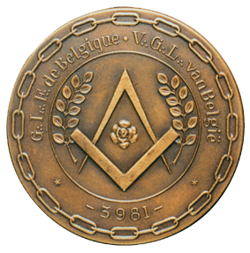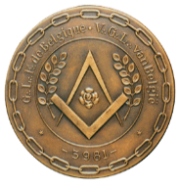

CLIMAF Colloquium – 16th April 2016

Centre de Liaison International de la Maçonnerie Féminine

**Women’s Freemasonry in the 21st century.**

**What kind of commitment ?**

**Programme**

***Venue for all activities : rue du Persil 8, 1000 Brussels***

8h30 Arrival and welcome – Registration for the round tables

9h30 Opening of the Colloquium by

* the President of CLIMAF
* the M∴W∴G∴M∴ of the GLFB-VGLB

Round tables

1. Commitment in the Lodge. What does being initiated mean in the 21th century? And why opt for a female Obedience?
2. Commitment in the profane world. The ethical challenge in today’s world.
3. Commitment in Europe. How to defend our values?

12h30 Lunch

14h00 Lectures

* *Quality education and the teaching of values in the 21stcentury for the 22nd century* by S∴ Raymonda Verdyck of the W∴L∴ Vega, E∴ Mechelen, GLFB-VGLB
* *Women’s Freemasonry in Europe* by S∴ Véronique De Keyser of the W∴L∴ La Pierre franche, E∴ Liège, GLFB-VGLB

17h00 Solemnly meeting

----------------------------------------------------

***Venue for the banquet : rue de Laeken 79, 1000 Brussels***

20h00 Dinner